The maps below show the changes that have taken place in Meadowside village and Foton, a neighbouring town, since 1962.

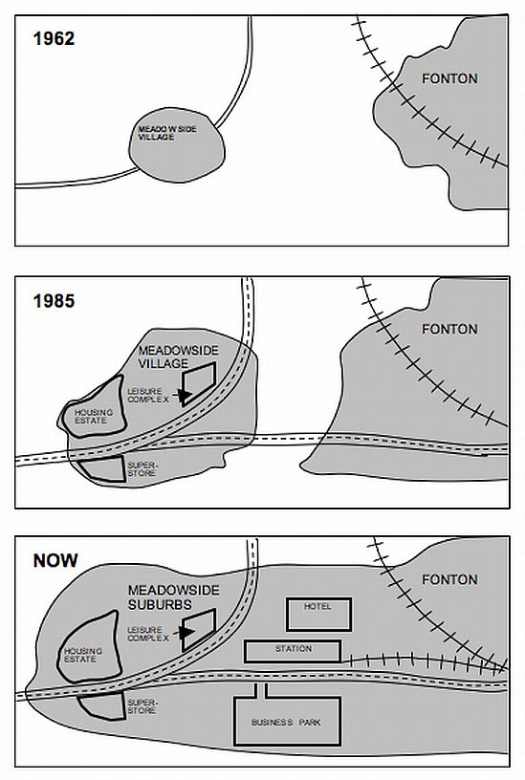

[Model answer](https://ieltsliz.com/ielts-map-model-answer/)

The Changes of Meadowside Village and Foton

*The first edition.*

These three maps illustrate how Meadowside village and Foton have developed from 1962 to the present. In general, they are in chronological order from the top to the bottom.

First of all, in 1962 the village was very small with only one narrow path passing through it. At that time there was not any road to Foton.

Whereas, Meadow has expanded by 1985 and the main road was wider than before. A new road had been built to Foton. Residential area was larger and new houses and a supermarket were constructed on the two sides of the main road in the west part of the village. Furthermore, there was a new leisure complex located in the eastern side.

Finally, a new railway has been construted from Foton to Meadow and the two places have been merged together. There is a new hotel built right behind the train station. In addition, a ~~bussiness~~ park has been built beside the road to Foton.

In conclusioin, the village has been transformed dramatically over the past few decades. It eventually becomes closer and closer to the towns nearby.

Feedback form ChaGPT and Bard

Inappropriate expression

1, “Residential area was larger..”

The residential area had grown.

2. “new houses and a supermarket were constructed on the two sides of the main road”

… were constructed on both sides of the main road.

3. “in the eastern side”

on the eastern side

4. “they are in chronological order from the top to the bottom.”

-> the maps arranged in chronological order from top to bottom.

5. “the village has been transformed dramatically over the past few decades. It eventually becomes closer and closer to the towns nearby”

-> the village has been transformed dramatically over the past few decades, becoming increasingly integrated with neary towns.

Wrong words:

1, ~~bussiness~~

business

2. In ~~conclusioin~~

In conclusion

Wrong punctuation

1. “, Meadow has expanded by 1985 and the main road was wider than before.”

->…by 1985**,** and the main road..

Additional Suggestioins

1. “a new railway has been construted from Foton to Meadow and the two places have been merged together”

In order to emphasise that the railway links the two areas, the sentence can be changed to:

“a new raiway has been constructed linking Fonton to Meadowside”.

Guidence:

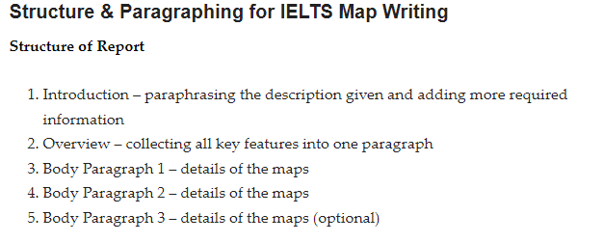

**The IELTS map model answer is Band Score 9.**

*IELTS Map Comparison Model Answer*

The three maps illustrate how Meadowside village and Fonton, which is a nearby town, have developed from 1962 to the present.

Overall, both Fonton and Meadowside village increased in size over the years until they eventually merged together, at which point Meadowside became a suburb. Furthermore, there have been significant changes to infrastructure, housing and facilities over the period given.

In 1962, both Meadowside and Fonton were completely separate with no roads or rail connecting them. While Fonton had a railway line running to the north, Meadowside, located to the west of Fonton, only had a small road from the west.

By 1985, Meadowside had expanded and the small road had become a main road. A further main road had been built to connect the village to Fonton. Within Meadowside, a superstore, leisure complex and housing estate had been developed. By this time, Fonton had also grown in size.

Currently, Meadowside is known as Meadowside Suburbs after joining with Fonton.

Between both places, a hotel, station and business park have been built on either side of the railway line.